**Smart Traffic Light System Using Deep Learning and Image Processing with YOLO v7**

**Abstract:**

In India, traffic congestion is a serious issue that affects both urban and rural areas and has a substantial negative economic and environmental impact. The dynamic and erratic character of traffic at intersections, particularly during peak hours, is beyond the scope of traditional traffic management systems, which follow set, time-based schedules. Due to extended periods of vehicle idling and stop-and-go driving, this inefficiency not only increases wait times and driver annoyance but also raises fuel consumption and pollution. These traditional technologies' flaws highlight the need for more intelligent, flexible solutions. Our technology can precisely identify and analyse traffic density by using YOLO v7 (You Only Look Once, version 7) for object detection. This allows us to dynamically modify signal timings to better control vehicle flow. Famous for its speed and accuracy, YOLO v7 performs better than earlier iterations and alternative object identification models, which makes it ideally suited for real-time applications where quick decisions are crucial. Our solution uses YOLO v7's capabilities to optimize traffic control and minimize needless delays, which improves road safety, streamlines traffic flow, and lowers emissions. By incorporating responsive and adaptable technology into traffic management, this method significantly outperforms traditional systems and eventually fits in with the objectives of sustainable urban planning and smart city infrastructure.

**Keywords—** Smart traffic management, deep learning, image processing, YOLO v7, real-time object detection, adaptive traffic control, traffic congestion reduction, traffic signal optimization and intelligent transportation systems (ITS), smart city infrastructure.

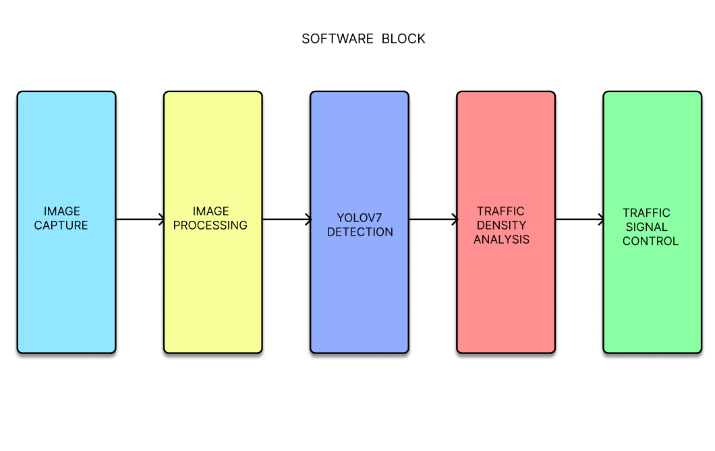

**Working Principle:**

Through real-time object identification, our smart traffic light system effectively manages traffic using YOLOv7, an advanced deep learning model. Fast, on-site data processing is made possible by edge AI devices like the Nvidia Jetson and Intel Neural Compute Stick, which reduce delays and guarantee that traffic signals react dynamically to the situation at hand. Because it can identify objects with 40% less parameters and 50% less processing than other models, YOLOv7 is selected to manage situations with high traffic densities and identify important vehicles, like ambulances, for priority passage.

There are three primary components to the YOLOv7 architecture: (3) Head (Re-parameterized Convolution), which improves processing efficiency for lane occupancy and vehicle recognition; (2) Neck (Compound Scaling), which adjusts resolution, depth, and width for a variety of application use; and (3) Backbone (E-ELAN), which maximizes learning while maintaining gradient paths. Even at intricate intersections, this architecture enables precise, effective detection.

Using a webcam, the system takes real-time lane photos, which are then analysed using Canny Edge Detection to provide accurate object recognition. After detecting and counting cars, YOLOv7 modifies signal timings to reduce idle time and alleviate traffic in congested lanes. Furthermore, emergency cars are identified by colour-based segmentation, which dynamically modifies lights to enhance intersection safety and traffic flow.

**Existing Systems:**

Assigning a traffic police officer to oversee traffic at intersections is known as manual traffic control. The officer controls traffic flow in real time using hand signals, a whistle, and occasionally signs or light boards. This strategy, while useful in some circumstances, is constrained by the officer's physical capabilities, making it difficult to sustain effectiveness, particularly during periods of high traffic. In addition to being labour-intensive and prone to human mistake, manual control might result in irregular signal timing. It also puts a physical strain on traffic cops, who have to deal with difficult weather and environmental circumstances. Due to differences in signalling, drivers frequently experience confusion and delays when using manual control. Signal lights are controlled by automatic traffic control using timers and preset patterns. The majority of these systems are time-based, which means that regardless of the real traffic circumstances, the traffic signal cycles through the red, yellow, and green phases at predetermined intervals. To identify the presence of a vehicle, some configurations use electromagnetic sensors; yet, these systems still primarily rely on strict timing intervals. These time-based automatic systems are convenient, but they often result in inefficiencies. For example, they may signal a lane to stop even when it is empty, while cars are lining up in another lane, waiting to move forward. These strict procedures can lead to needless delays and annoyance, particularly when traffic is heavy or the flow of traffic is unexpected.

**Limitations:**

* Manual traffic control relies heavily on human input, which can be exhausting and inconsistent.
* Time-based automatic systems frequently result in delays in lanes that require green signals because they are unable to adjust to the real-time flow of traffic.
* Driver stress and delay can be caused by both manual and automatic systems, which may compromise safety.
* While automatic systems require regular technical maintenance and can experience additional disruptions due to malfunctions, manual control necessitates personnel.

**Proposed Systems:**

With the help of edge AI devices like the Nvidia Jetson and Intel Neural Compute Stick, which allow on-site data processing for reduced latency and improved real-time responsiveness, our suggested smart traffic light system uses deep learning and image processing to dynamically manage traffic flow at intersections. YOLO v7, a cutting-edge object identification algorithm developed in Python using PyCharm, is the central component of this system. By identifying lane occupancy, vehicle density, and priority for vital vehicles like ambulances, the system maximizes traffic flow. Due to its effective processing capabilities, YOLO v7 can analyse vast amounts of pictures and video in real time and provide data-driven signal timing modifications. YOLO v7 allows for dynamic signal modifications by comparing real-time traffic photographs with historical trends, which decreases idle time in low-traffic lanes and easing congestion in high-density lanes. The timer allocation system modifies traffic light intervals in accordance with the traffic data processed by YOLO v7. This minimizes needless delays by extending red signals for empty lanes and green light periods for lanes with high traffic. Because of its special single-pass detection, YOLO v7 can recognize objects quickly and precisely, which makes it perfect for real-time traffic changes in congested intersections. By using this method, the suggested system provides a quick and effective way to manage traffic, reducing wait times and guaranteeing more seamless traffic flow.

**Advantages:**

* Shortens wait times by dynamically modifying signal timings in response to actual traffic load.
* Optimizes traffic flow at intersections by reducing traffic jams and idle time.
* Lower pollutants and fuel consumption are the results of less vehicle idling.
* Identifies and prioritizes emergency vehicles so they can quickly navigate junctions.